**Ann Walker (1803-1854)**

**Ivana Nika**

**Place: Canterbury, 12-13 June 1834**

**The landowner and diarist [Ann Walker](**https://en.wikipedia.org/wiki/Ann_Walker_(landowner)) **of Lightcliffe in Yorkshire passed through [Canterbury](/19c/19c-canterbury) (and Kent) with [Anne Lister](**<https://yorkcivictrust.co.uk/heritage/civic-trust-plaques/anne-lister-1791-1840/>**) of [Shibden Hall, Halifax](**[**https://museums.calderdale.gov.uk/visit/shibden-hall**](https://museums.calderdale.gov.uk/visit/shibden-hall)**) on their way to France and Switzerland in the summer of 1834. Their relationship and (not legally recognised) [marriage](**<https://yorkcivictrust.co.uk/heritage/civic-trust-plaques/anne-lister-1791-1840/>**) is the subject of the recent BBC/Lookout Point TV drama series [“Gentleman Jack”.](https://www.bbc.co.uk/programmes/m00059m9). Although her stay in [Canterbury](/19c/19c-canterbury) was short, Ann Walker wrote a long account of it in her recently discovered and fully transcribed [journal.](**[https://www.catalogue.wyjs.org.uk/CalmView/Record.aspx?src=CalmView.Catalog&id=WYAS4971%2f7%2f1%2f5%2f1](https://www.catalogue.wyjs.org.uk/CalmView/Record.aspx?src=CalmView.Catalog&id=WYAS4971%2F7%2F1%2F5%2F1)**). Anne Lister also noted details of their stay in Canterbury (and Kent) in her own diary.**

On 12 June 18341 Ann Walker and Anne Lister arrived in **[Canterbury](/19c/19c-canterbury)** late at night, in their carriage, with two of their servants. Ann notes in her diary how they missed out on seeing Rochester Cathedral on the way due to rain. They booked rooms at The Fountain [<http://www.machadoink.com/Royal%20Fountain%20Hotel.htm>] in St Margaret's Street, which had been claimed to be one of the oldest coaching inns in the country, but was sadly destroyed in air raids in 1942.

On 13 June 18342 Ann Walker wrote a detailed account of the day. In the morning Anne and Ann visited Canterbury Cathedral, in the afternoon strolled down Dane John Gardens, briefly saw Canterbury castle, and climbed up Dane John Mound.

Canterbury Cathedral is described in great detail in Ann Walker’s journal, which includes many historical facts about its chapels, aisles, shrines, tombs, and monuments dedicated to former archbishops3. Judging by the similarities of syntax and detail, some sentences in her journal might have been copied or adapted from _A Walk In and About the City of Canterbury_,4  a book compiled by William Gostling, which had seen several editions by 1834.

Similarly, she provides a detailed account – including extensive information on its dimensions – of the promenade in the Dane John Gardens,5 which was created between 1790-1803when the gardens were gifted to the town by [Aldermann James Simmons](https://en.wikipedia.org/wiki/James_Simmons_(1741%E2%80%931807)), and to whom the memorial on the top of the mound was erected in 1803 by public subscription.6 The Norman castle, which unsurprisingly “has no appearance of Roman antiquity” is also described7. Afterwards Ann Walker praises **[Canterbury](/19c/19c-canterbury)** shops, which were at the time famous for their trade in silk and [brawn](<https://en.wikipedia.org/wiki/Head_cheese>), and buys some oranges.

After a stroll down **[Canterbury](/19c/19c-canterbury)** streets, Walker and Lister finally left for [Dover](/19c/19c-dover), where they took lodgings at the [Ship Inn](http://www.dover-kent.com/Ship-Hotel.html), which, as Walker mentions, had just changed hands (passing from a Mr. C. Wright to a Mr. Worthington). Before dinner, Ann Walker played the inn’s piano, and the next morning the two women took passage on a packet boat “Ferret” to Calais.8

On their return journey from the Continent, Ann stopped writing in her journal once they arrived in Calais. We, however, do know from Lister's diary that after their return to England on the packet boat Firefly on 26 August9, they passed through [Dover](/19c/19c-dover) and **[Canterbury](/19c/19c-canterbury)** without stopping. They spent a night in Rochester (at Wright’s Hotel) on their way to London, before ultimately travelling to their home – Shibden Hall in Halifax.

The [In Search of Ann Walker](<https://insearchofannwalker.com/>) research collaborative works on bringing to light all aspects of Ann's life.

**Notes**

1 Diary Comparison Portal, <https://insearchofannwalker.com/thursday-12th-june-1834/>

2 Diary Comparison Portal, <https://insearchofannwalker.com/friday-13th-june-1834/>

3 Canterbury Cathedral, <https://www.canterbury-cathedral.org/>

4 William Gostling: A Walk In and About the City of Canterbury, <https://archive.org/details/walkinaboutcityo00gost/page/n7/mode/2up>

5 Dane John Gardens, <http://www.canterbury-archaeology.org.uk/dane/4590809480>

6 The Dane John / Dungeon, <http://www.machadoink.com/Dane%20John.htm>

7 Canterbury Castle, <http://www.canterbury-archaeology.org.uk/castle/4590809462>

8 Packet Service I to 1854, <https://doverhistorian.com/2015/03/21/packet-service-to-1854/>

9 Diary Comparison Portal, <https://insearchofannwalker.com/tuesday-26th-august-1834/>

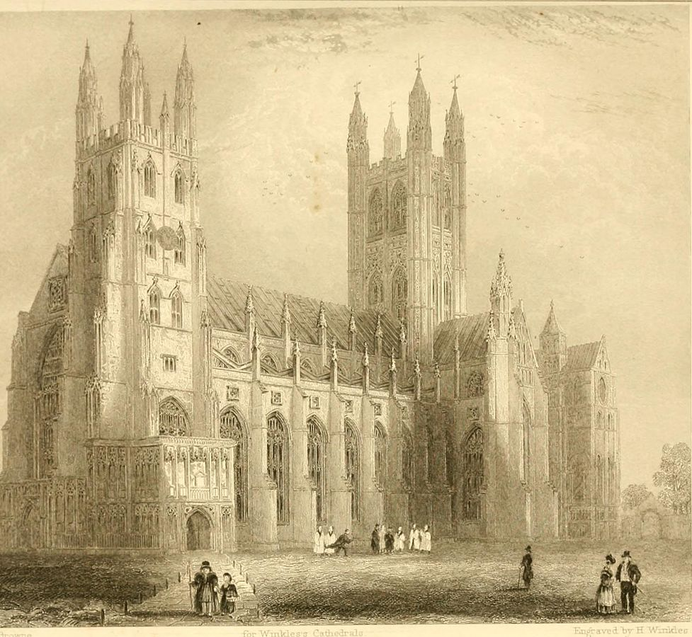

Canterbury Cathedral, from A Walk In and About the City of Canterbury by William Gostling, 1825. No known copyright restrictions.

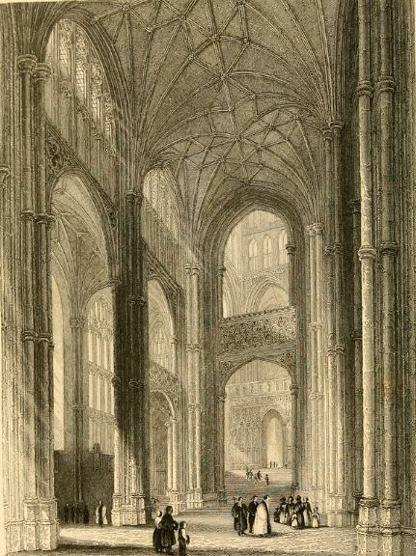

Canterbury Cathedral, from A Walk In and About the City of Canterbury by William Gostling, 1825. No known copyright restrictions.

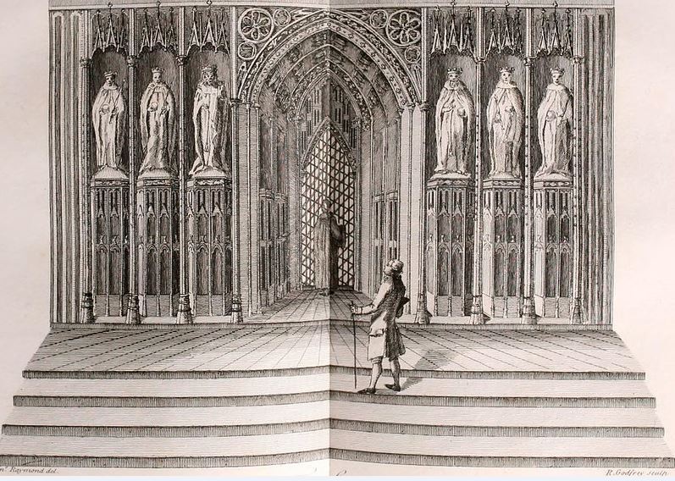 Canterbury Cathedral, from A Walk In and About the City of Canterbury by William Gostling, 1825. No known copyright restrictions.

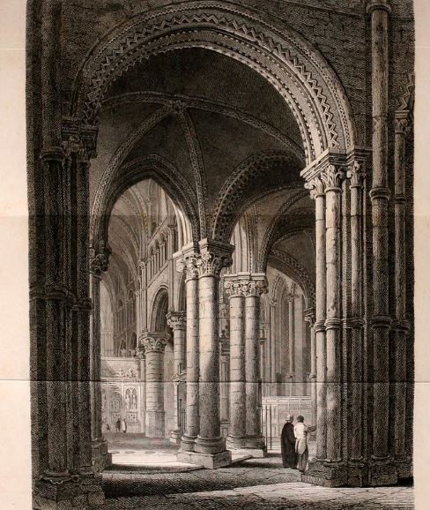

Canterbury Cathedral, from A Walk In and About the City of Canterbury by William Gostling, 1825. No known copyright restrictions.

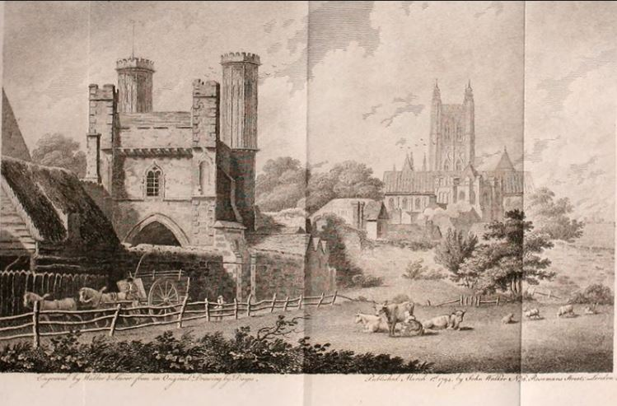

Canterbury Castle, from A Walk In and About the City of Canterbury by William Gostling, 1825.

No known copyright restrictions

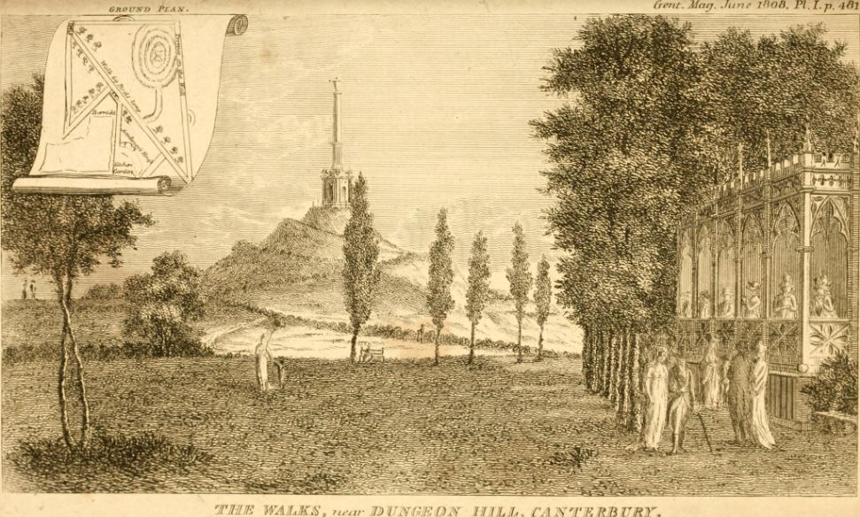

Dane John Gardens, from A Walk In and About the City of Canterbury by William Gostling, 1825.

No known copyright restrictions

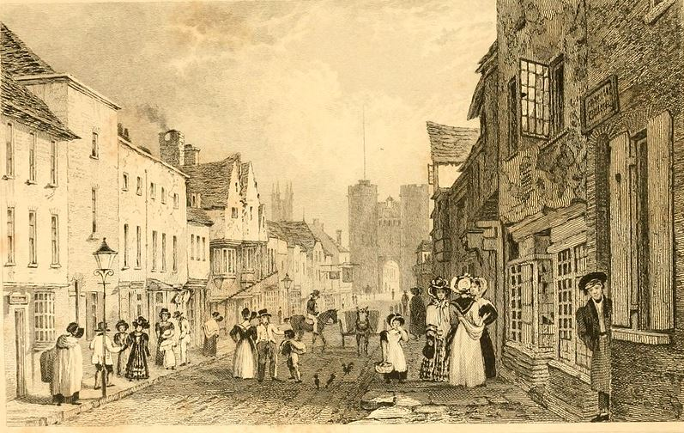

Canterbury street, from A Walk In and About the City of Canterbury by William Gostling, 1825.

No known copyright restrictions

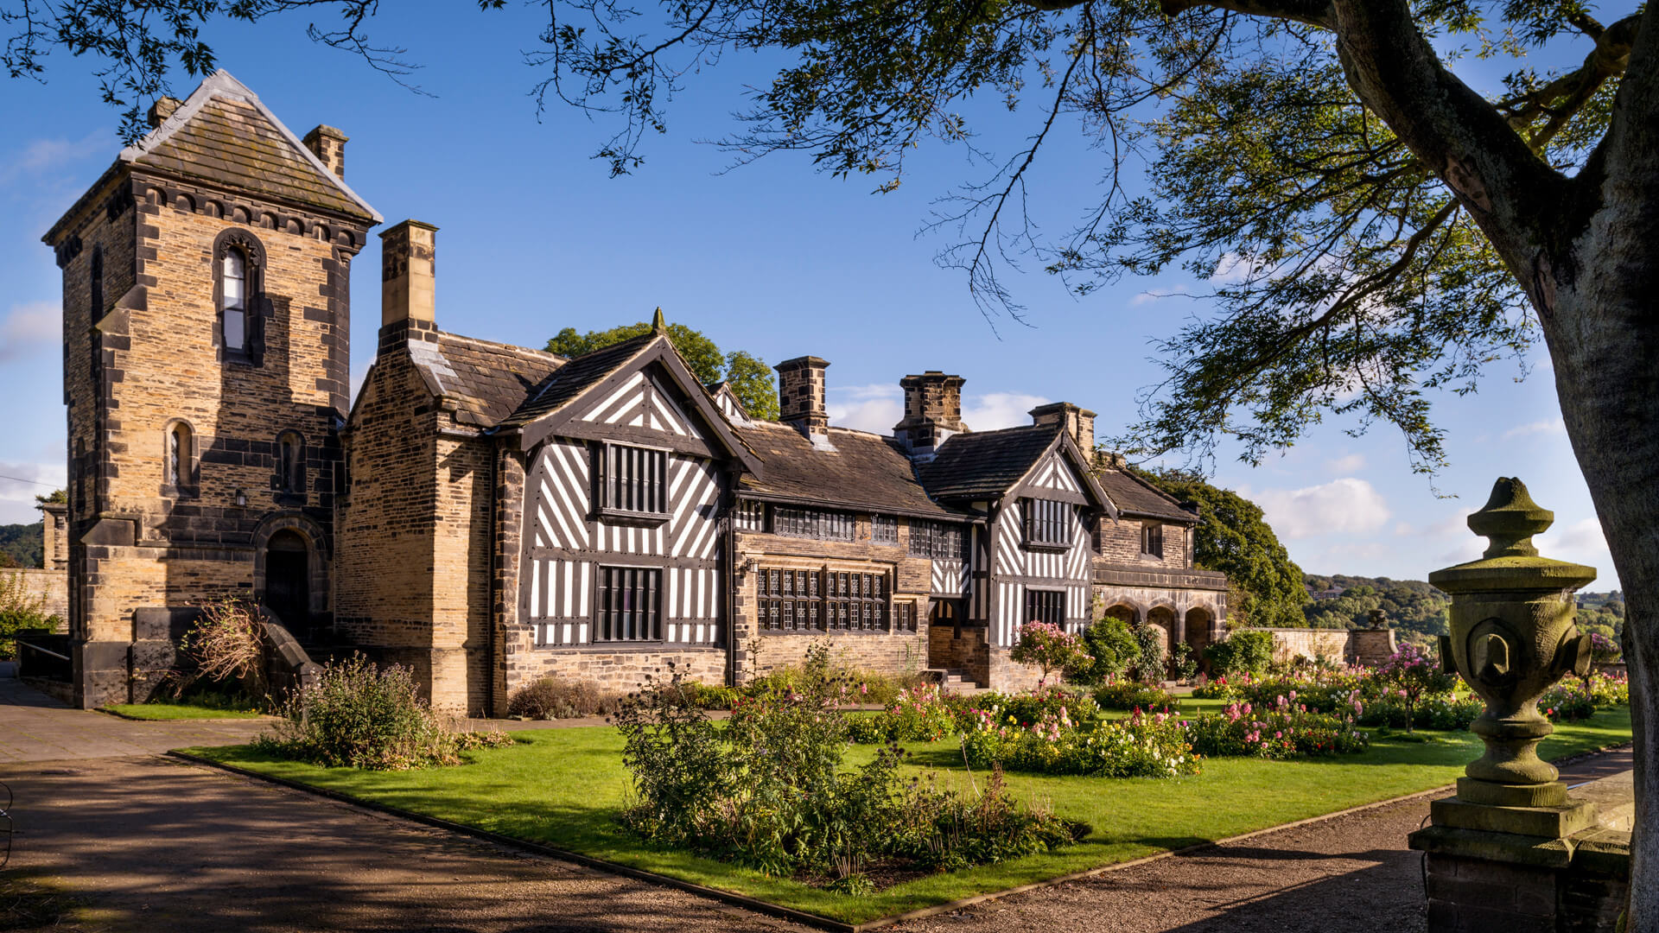

Shibden Hall, Halifax, Credit: Calderdale Museums

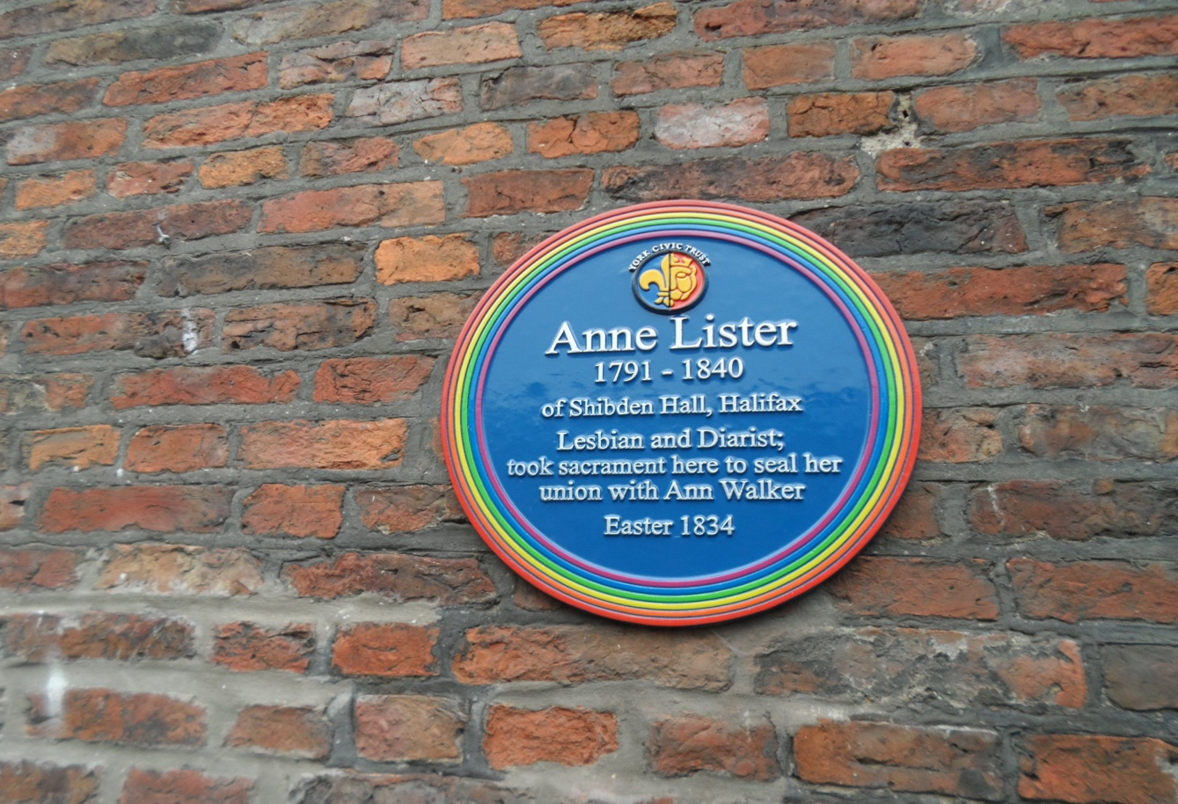

Rainbow plaque at Holy Trinity church, Goodramgate, York. Credit: Ivana Nika